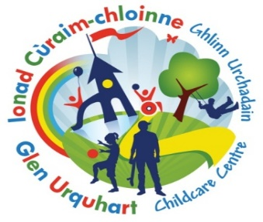


Nursery/P1 Balnain Primary Transition Timetable
2025 – 2026
 | Date | Activity
November | 26.11.25 | Mrs MacLeod initial visit to meet children at nursery
December | 3.12.25  11.12.25  17.12.25 | Mrs MacLeod to join nursery session 9-10am  Children & Families are invited to come along to the Christmas Craft Fair at  Balnain Hall  from 10:00-11:30am  Mrs MacLeod to watch nursery performance
January | 21.01.26 | Balnain Teachers to join nursery session 9-10am
February | 10.02.26 | Bookbug and play session at the School 2pm – 3pm
March | 25.03.26 | Balnain Teachers to join nursery session 9-10am
April | -------- | Easter Holidays
May | 14.05.26  Date TBC | Stay & Play session at Balnain  9am – 10am  Balnain Sports day. Nursery children invited to join us at Cannich Shinty Pitch
June | Transition Week  W/B - 22.06.26  Parent Info Session | Tue 23th – 9am -11am  Wed 24th – 9am-11am  Thur 25th – 9am-1.30pm  (Staying for Lunch)  TBC during transition week

