
Glen Urquhart Childcare Centre
Holiday Club
Monday 14th – Friday 18th October 2024
9AM – 5.30PM
Phone: 01456 450 679 E mail: bookings@glenurquhartchildcarecentre.co.uk
Scottish Charitable Incorporated Organisation SCO24692
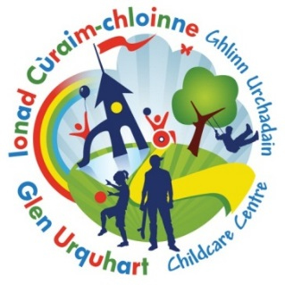

What we offer………..
Full day from 9am – 5.30pm - £42 (includes snacks and activity)
Half day AM from 9am – 1.15pm – £21 (includes snack and activity)
Half day PM from 1.15pm – 5.30pm - £21 (Includes snack and activity)

Monday 14th October | Tuesday 15th October | Wednesday 16th October | Thursday 17th October | Friday 18th October
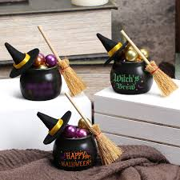  Decorate your own ceramic Cauldron |   Make and decorate your own spooky cake |   Halloween Craft Day |   Trip to Fort George |   Halloween Party day

Booking Form
Please note all bookings are non-refundable and will be charged if you choose to amend or cancel

Child’s Name …………………………………………… Age………… Mobile number ………………………………………………………………………….

Date | Please note below if you require the FULL day or HALF DAY | Should anyone have any information they wish to share with staff, please note below:
Mon 14th Oct
Tue 15th Oct
Wed 16th Oct
Thru 17th Oct
Fri 18th Oct

Book by Monday the 7th of October to receive our Early bird special discount
Full day £37 or Half Day £18.50

