Glen Urquhart Childcare Centre
Holiday Club
Monday 3rd of April – Thursday 6th April 2023
9AM – 6PM
Phone: 01456 450679 E mail: Bookings@glenurquhartchildcarecentre.co.uk
Scottish Charitable Incorporated Organisation SCO24692
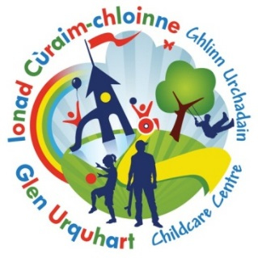

 Book by Monday the 27th of March to receive our Early Bird Discount - £34 Full day or £18 Half Day
Monday 3rd April | Tuesday 4th April | Wednesday 5th April | Thursday 6th  April
  Craft Day  (Hama beads/ Tie dye paints/chalk markers, face paints) |   Easter Egg Hunt |   Pizza Making | 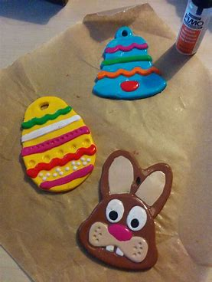  Easter Fimo Craft

Booking Form

Please note that once a booking has been made charges will apply

Child’s Name …………………………………………… Age………… Mobile number ………………………………………………………………………….

Date | Please note below, if you require the FULL day or HALF DAY | Should anyone have any information they wish to share with staff, please note below:
Mon 3rd April
Tue 4th April
Wed 5th April
Thur 6th April

Full day Holiday club day (9am -6pm) - £40
Half day Holiday club (9am-1.30pm or 1.30pm-6pm) - £22

PLEASE RETURN BY 27th of March to ensure you receive the “EARLY BIRD DISCOUNT” THANK Y0U

