Glen Urquhart Childcare Centre
Holiday Club
Monday 12th and Tuesday 13th of September 2022
9AM – 6PM
Phone: 01456 450679 E mail: assistantmanger@glenurquhartchildcarecentre.co.uk
Scottish Charitable Incorporated Organisation SCO24692
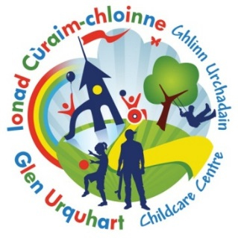

Book by Tuesday the 5th of September to receive our
Early Bird Discount - £34 Full day or £18 Half Day
Monday 12th of September  Great British Bake Off   | Tuesday 13th of September  Craft day  

Booking Form

Scottish Charitable Incorporated Organisation SC024692
Please note that all childcare hours booked will be invoiced.

Child’s Name …………………………………………… Age………… Mobile number ………………………………………………………………………….

Date | Please note below, if you require the FULL day or HALF DAY | Should anyone have any information they wish to share with staff, please note below:
Mon 12th Sep
Tue 13th Sep

Holiday club is £22 for a half day: 9am -1.30pm or 1.30pm – 6pm, or £40 for a full day.
However, you can take advantage of our EARLY BIRD DISCOUNT OF £18 per half day or £34 for a full day
PLEASE RETURN BY 5th of September to ensure you receive the “EARLY BIRD DISCOUNT” THANK Y0U

