
Glen Urquhart Childcare Centre Lunch Menu

WEEK 1: Week Commencing: 4th January, 1st February, 1st March, 29th March

Monday    Fish Fingers, peas, and potato wedges | Tuesday  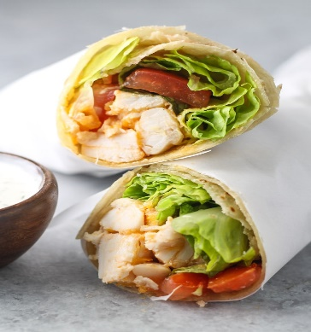  Chicken & Lettuce  Wrap | Wednesday    Homemade burger in a bun with lettuce | 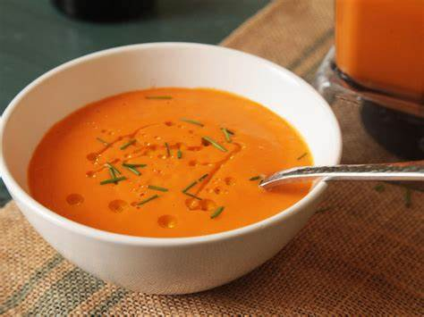  Thursday  Carrot and Lentil soup with toasties (ham/cheese) |   Friday  Homemade Pizza with a selection of toppings  - Polish Kabanos  - Cheese  - Peperoni  - Pineapple
Cereal Bar | Blueberry Muffin | Fruit Cocktail with Sorbet | Yoghurt | Angel Delight

Glen Urquhart Childcare Centre Lunch Menu

WEEK 2: Week commencing: 11th January, 8th February, 8th March

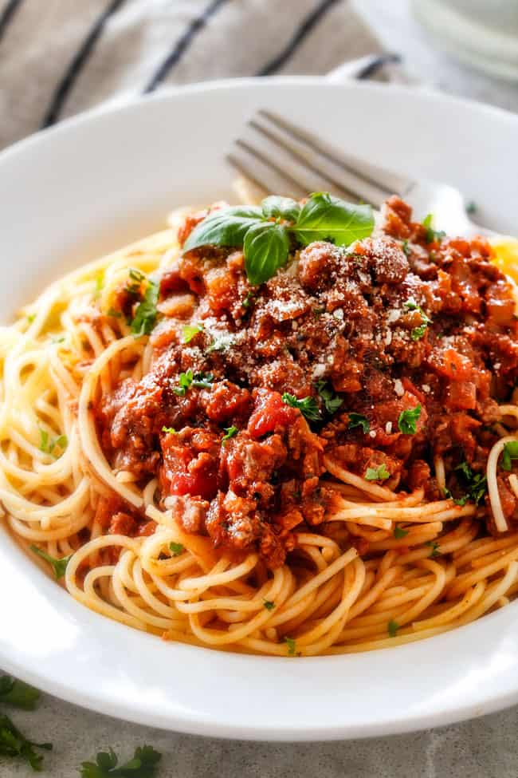  Monday  Spaghetti Bolognese | Tuesday    Sausage in a roll | Wednesday    Chicken goujons, boiled potatoes and vegetables | Thursday  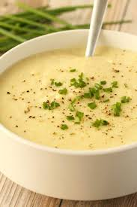  Potato and Leek soup with toasties (Tuna, Cheese, Ham) | Friday  Chicken & Lettuce Wrap
Yoghurt | Vanilla cupcakes | Custard & Banana | Fruit Cocktail and Sorbet | Blueberry Muffin

Glen Urquhart Childcare Centre Lunch Menu

WEEK 3: Week commencing: 18th January, 15th February, 15th March

Monday  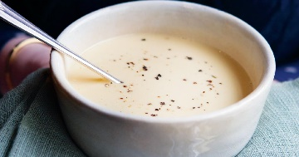  Chicken Soup and Sandwich (Ham, Cheese, Tuna) | Tuesday  Homemade Burger in a bun |   Wednesday  Tomato Pasta & Garlic Bread | 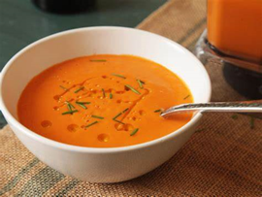  Thursday  Vegetable Soup and toasties (Ham, cheese, tuna) | Friday  Sausage in a bun
Fruit Cocktail and Sorbet | Yoghurt | Vanilla Cupcake | Blueberry Muffin | Custard and Banana
Glen Urquhart Childcare Centre Lunch Menu

WEEK 4: Week Commencing: 25th January, 22nd February, 22nd March

Monday    Fish Fingers, potato wedges & peas | Tuesday    Homemade sausage rolls | 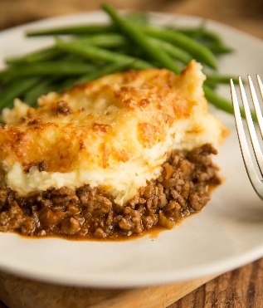  Wednesday  Shepherd’s Pie with Peas | Thursday    Chicken noodle soup | Friday    Baked potatoes, coleslaw, and a selection of fillings
Custard & Banana | Fruit Cocktail & Sorbet | Blueberry muffin | Cereal bars | Yoghurt

