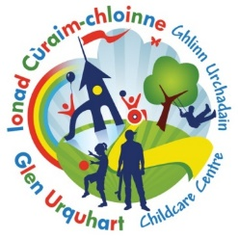
Glen Urquhart Childcare Centre
Lunch Menu
WEEK 1: Week commencing 26th October 23rd November, 14th December

Monday  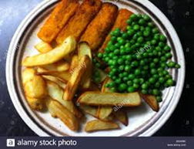  Fish Fingers, peas and potato wedges | Tuesday    Chicken Fajitas | 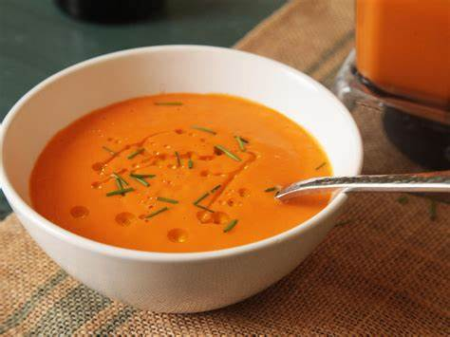  Wednesday  Carrot and Lentil soup with toasties (ham/cheese) | Thursday    Homemade burger in a bun with lettuce |   Friday  Homemade Pizza with a selection of toppings  - Polish Kabanos  - Cheese  - Peperoni  - Pineapple
Cereal Bar | Blueberry Muffin | Fruit, pancakes &  cream | Yoghurt | Angel Delight

Glen Urquhart Childcare Centre
Lunch Menu
WEEK 2: Week commencing 2nd November, 30th November, 21st December

Monday  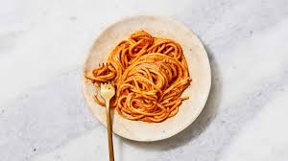  Pesto (nut free) and pasta | Tuesday  Homemade pizza, salad & seasonal vegetables | Wednesday  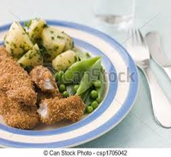  Chicken goujons, boiled potatoes and vegetables | Thursday  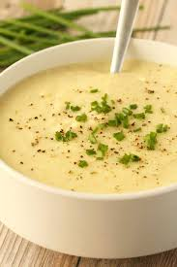  Potato and Leek soup with toasties (Tuna, Cheese, Ham) | Friday    Sausage in a roll
Yoghurt | Vanilla cupcakes | Custard & Banana | Fruit, cream & pancakes | Blueberry Muffin
Glen Urquhart Childcare Centre
Lunch Menu
WEEK 3: Week commencing 9th November 7th December

Monday  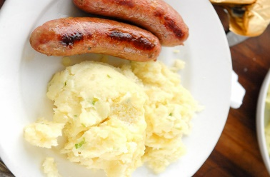  Sausage, mash, and vegetables | Tuesday    Potato, cheese, and bacon frittata | Wednesday  Fish fingers, peas, and wedges | Thursday    Chicken fried rice | Friday  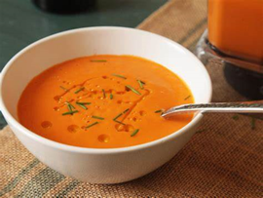  Lentil Soup and toasties (Ham, cheese, tuna)
Fruit, cream & pancakes | Yoghurt | Vanilla Cupcake | Blueberry Muffin | Custard and Banana
Glen Urquhart Childcare Centre
Lunch Menu
WEEK 4: 16th November, 14th December

Monday    Fish Fingers, potato wedges & peas | Tuesday  Sweet Potato and Butternut squash soup & sandwiches (ham, cheese & tuna) | Wednesday    Homemade sausage rolls | Thursday  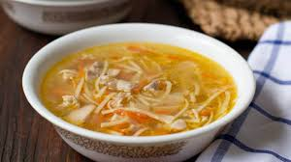  Chicken noodle soup | Friday  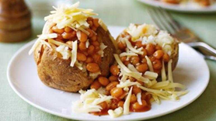  Baked potatoes, coleslaw, and a selection of fillings
Custard & Banana | Fruit, cream, and pancakes | Blueberry muffin | Cereal bars | Yoghurt

