Glen Urquhart Childcare Centre
Holiday Club
Monday 14th September – Tuesday 15th September 2020
8AM – 6PM
Phone: 01456 450679
E mail: bookings@glenurquhartchildcarecentre.co.uk
Scottish Charitable Incorporated Organisation SCO24692

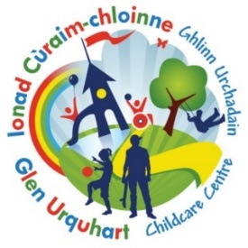


EARLY BIRD EXTENTION!!
Return by Monday 7th September to receive our discount £34 Full Day or £18 Half Day!

Booking Form

Please note that once a booking has been made charges will apply

Child’s Name …………………………………………… Age ………… Mobile number ………………………………………………………………………….

Date | Please note below if you require the FULL day or HALF DAY | Should anyone have any information they wish to share with staff, please note below:
Monday 14th September
Tuesday 15th September

Holiday club is £22 for a half day :8am -1pm or 1pm – 6pm, or £40 for a full day.
However, you can take advantage of our EARLY BIRD DISCOUNT OF £18 per half day or £34 for a full day

PLEASE RETURN BY 7th of September to ensure you receive the “EARLY BIRD DISCOUNT” THANK Y0U

