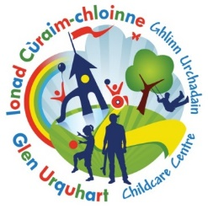
Glen Urquhart Childcare Centre
Lunch Menu
WEEK 1: Week commencing 18th August & 14th September

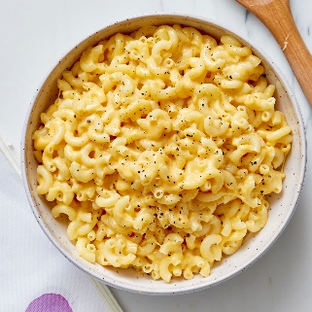  Monday  Macaroni Cheese & seasonal veg |   Tuesday  Homemade sausage roll, seasonal veg & boiled potatoes | 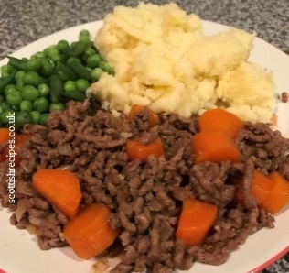  Wednesday  Mince & Tatties | Thursday  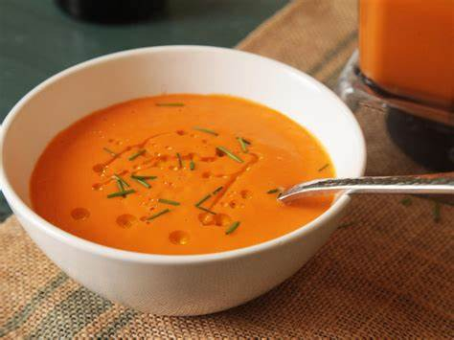  Homemade soup & choice of sandwiches (ham, cheese, tuna) | Friday  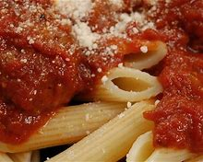  Tomato pasta bake
Yoghurt  &  Fresh Fruit | Home Bake | Yoghurt  &  Fresh Fruit | Home Bake | Yoghurt  & Fresh Fruit

Glen Urquhart Childcare Centre
Lunch Menu
WEEK 2: Week commencing 24th August & 21st September

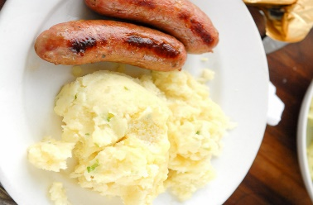  Monday  Sausages, seasonal veg & mashed potato |   Tuesday  Homemade pizza, salad & seasonal vegetables | Wednesday    Fish Fingers, potato wedges and peas | Thursday  Homemade soup with sandwiches (Tuna, Cheese, Ham) | Friday  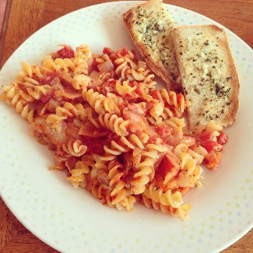  Herby tomato pasta, garlic bread and seasonal vegetables.
Yoghurt  & fresh fruit | Home Bake | Yoghurt & fresh fruit | Home Bake | Yoghurt & fresh fruit

Glen Urquhart Childcare Centre
Lunch Menu
WEEK 3: Week commencing 31st August & 28th September

Monday  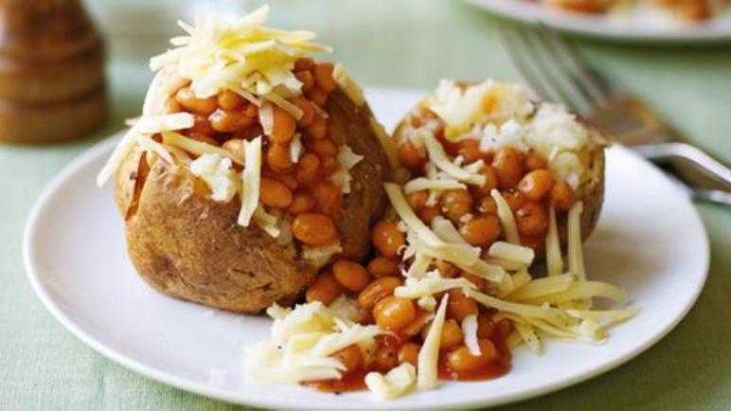  Jacket Potato with beans and/or cheese | Tuesday  Homemade Soup with sandwiches (ham, cheese or tuna) |   Wednesday  Sausage on a roll with seasonal vegetables | Thursday  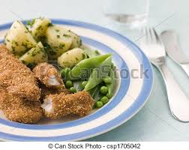  Chicken Goujons, seasonal veg & boiled potatoes | 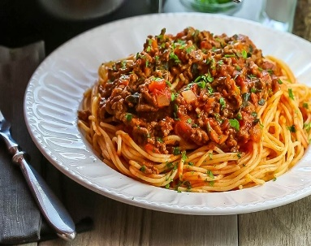  Friday  Pasta Bolognese, seasonal veg & garlic bread
Yoghurt & Fresh Fruit | Home Bake | Yoghurt & Fresh Fruit | Home Bake | Yoghurt & Fresh Fruit
Glen Urquhart Childcare Centre
Lunch Menu
WEEK 4: 7th September & 5th October

Monday  Fish Fingers, potato wedges & peas | Tuesday  Homemade soup & sandwiches (ham, cheese & tuna) | Wednesday  Mince & Tatties | Thursday  Homemade Pizza | Friday  Sausage on a roll with seasonal vegetables
Yoghurt  &  Fresh Fruit | Home Bake | Yoghurt  &  Fresh Fruit | Home Bake | Yoghurt  &  Fresh Fruit

