Glen Urquhart Childcare Centre
Holiday Club
Monday 16th and Tuesday 17th of September 2019
8AM – 6PM
Phone: 01456 450679 E mail: assistantmanger@glenurquhartchildcarecentre.co.uk
Scottish Charitable Incorporated Organisation SCO24692
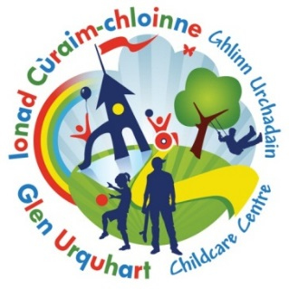

 Book by Monday the 9th of September to receive our Early Bird Discount - £34 Full day or £18 Half day
Monday 16th of September  Fimo and Baking day   | Tuesday 17th of September  Ceramic and Tile Decorating  
Booking Form

Scottish Charitable Incorporated Organisation SC024692
Please note that all childcare hours booked will be invoiced.

Child’s Name …………………………………………… Age………… Mobile number ………………………………………………………………………….

Date | Please note below, if you require the FULL day or HALF DAY | Should anyone have any information they wish to share with staff, please note below:
Mon 16th Sep
Tue 17th Sep

Holiday club is £22 for a half day :8am -1pm or 1pm – 6pm, or £40 for a full day.
However, you can take advantage of our EARLY BIRD DISCOUNT OF £18 per half day or £34 for a full day
PLEASE RETURN BY 9th of September to ensure you receive the “EARLY BIRD DISCOUNT” THANK Y0U

